FRMA AND FRM-200 ASSEMBLY

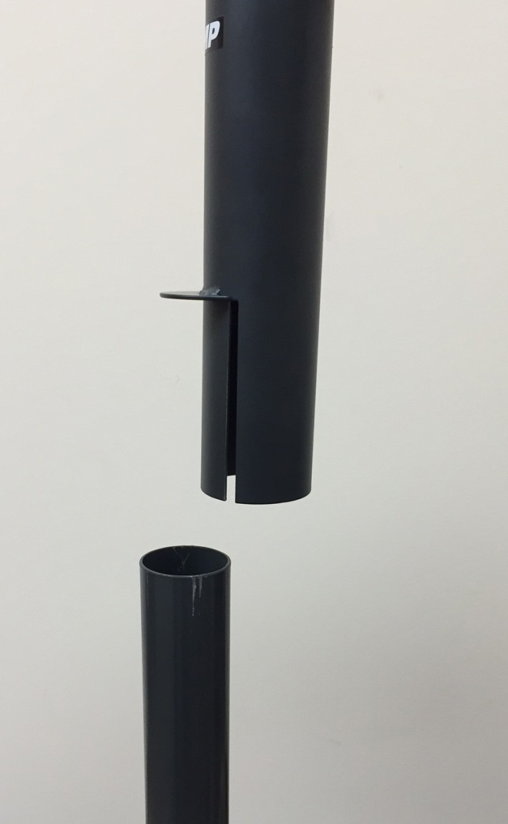 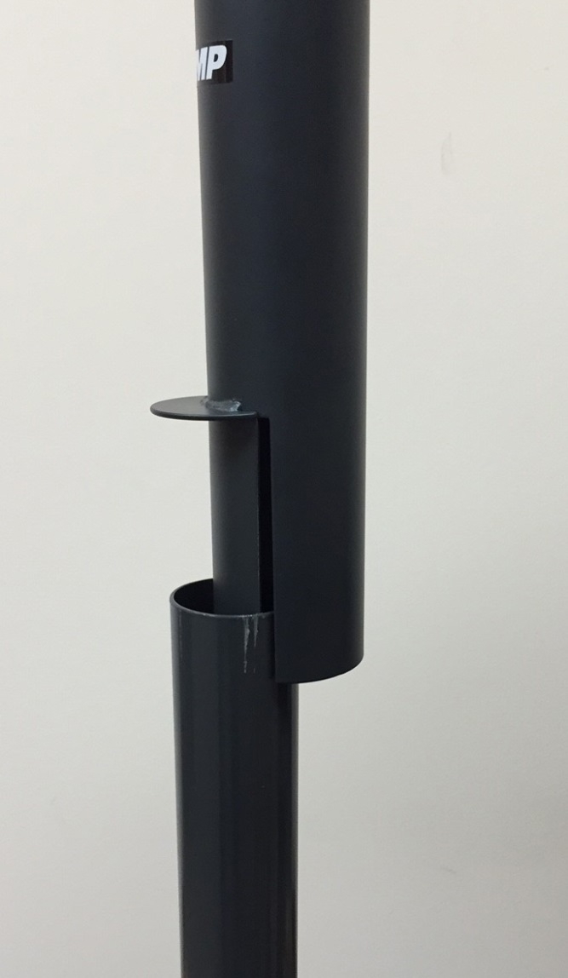 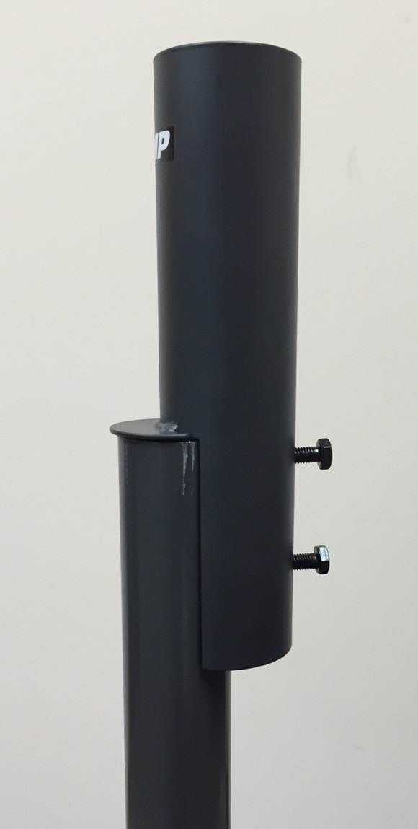

**STEP 1 STEP 2 STEP 3**

 877-281-2169 [www.videomount.com](http://www.videomount.com)